SUBJ: The Weeknd announces ‘The After Hours Tour’ starting June 11th

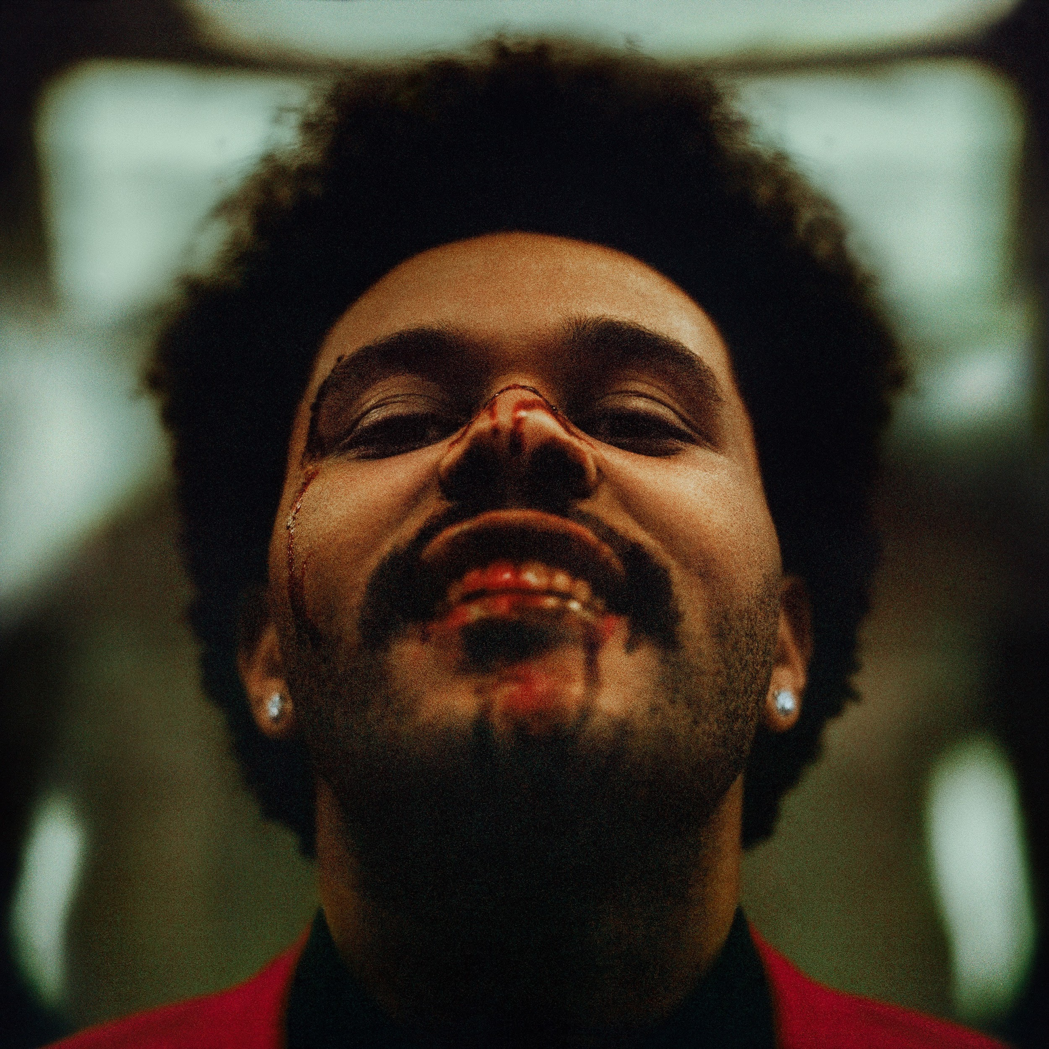

The Weeknd has announced his new headline world tour, The After Hours Tour, starting June 11th on the heels of his upcoming album, After Hours. American Express® Card Members can purchase tickets in select markets before the general public beginning Tuesday, February 25 at 10am local time (9am local time for UK/EU) through Thursday, February 27 at 10pm local time. During all US dates, Verizon Up ticket holders will get access to an exclusive stage side experience within the Verizon Up Members section. Regular ticket on-sale begins Friday, February 28 at 10am local time for North America and 9am local time for UK and EU.

The After Hours Tour will showcase state of the art production and one of the most innovative stage designs to date, containing the most LED lights and video for an arena show. Produced by Live Nation, the 57-date tour will hit cities across the United States, Canada, the United Kingdom, Belgium, the Netherlands, Germany and France with support from Sabrina Claudio and Don Toliver in the US, and 88GLAM and Sabrina Claudio in Europe.

After Hours album merch bundles became available with the announce of the title track and album pre-order yesterday, available at shop.theweeknd.com. For all North American dates, each ticket purchased online comes with one CD of The Weeknd's new album AFTER HOURS. All purchases of the album or album bundles via the UK webstore also give priority access to pre-sale tickets for the upcoming UK and EU tour dates (Note: pre-sale code applies to UK and EU dates only). Pre-sale (powered by Ticketmaster) begins at 9am GMT on Wednesday, February 26th.

On March 7th The Weeknd will perform on Saturday Night Live ahead of his new album, After Hours, dropping March 20th. Listen to the title track and get tickets at the links below.

Tickets for The After Hours Tour:
https://www.ticketmaster.com/the-weeknd-tickets/artist/1697014

Listen to “After Hours”:
http://theweeknd.co/afterhours-single

Pre-order After Hours:
https://umusic.digital/afterhours/

The After Hours Tour Dates:
June 11 - Vancouver, BC - Pepsi Live at Rogers Arena
June 14 - Edmonton, AB - Rogers Place
June 17 - Winnipeg, MB - Bell MTS Place
June 22 - St. Paul, MN - Xcel Energy Center
June 24 - Chicago, IL - United Center
June 26 - Pittsburgh, PA - PPG Paints Arena
June 27 - Detroit, MI - Little Caesar's Arena
June 29 - Toronto, ONT - Scotiabank Arena
June 30 - Toronto, ONT - Scotiabank Arena
July 2 - Montreal, QC - Bell Centre
July 4 - Uncasville, CT - Mohegan Sun
July 7 - Newark, NJ - Prudential Center
July 8 - Brooklyn, NY - Barclays Center
July 11 - Boston, MA - TD Garden
July 13 - Washington, DC - Capital One Arena
July 15 - Charlotte, NC - Spectrum Center
July 16 - Atlanta, GA - State Farm Arena
July 18 - Miami, FL - American Airlines Arena
July 21 - Orlando, FL - Amway Center
July 23 - New Orleans, LA - Smoothie King Center
July 24 - Houston, TX - Toyota Center
July 25 - Dallas, TX - American Airlines Center
July 27 - Denver, CO - Pepsi Center
July 29 - Salt Lake City, UT - Vivint Smart Home Arena
July 31 - Portland, OR - Moda Center
August 1 - Tacoma, WA - Tacoma Dome
August 3 - Oakland, CA - Oakland Arena
August 4 - San Jose, CA - SAP Center
August 6 - Sacramento, CA - Golden 1 Center
August 8 - Anaheim, CA - Honda Center
August 9 - San Diego, CA - Pechanga Arena
August 11 - Glendale, AZ - Gila River Arena
August 14 - Los Angeles, CA - Staples Center
August 15 - Los Angeles, CA - Staples Center
August 19 - San Antonio, TX - AT&T Center
August 20 - Ft. Worth, TX - Dickies Arena
August 22 - Tulsa, OK - BOK Center
August 23 - Omaha, NE - CHI Health Center Omaha
August 25 - St. Louis, MO - Enterprise Center
August 26 - Nashville, TN - Bridgestone Arena
August 28 - Cleveland, OH - Rocket Mortgage FieldHouse
September 1 - Buffalo, NY - KeyBank Arena
September 3 - New York, NY - Madison Square Garden
October 11 - London, UK - O2 Arena
October 12 - London, UK - O2 Arena
October 13 - London, UK - O2 Arena
October 15 - Newcastle, UK - Metro Radio Arena
October 16 - Birmingham, UK - Arena Birmingham
October 18 - Glasgow, UK - SSE Hydro
October 19 - Manchester, UK - Manchester Arena
October 26 - Antwerp, Belgium - Sportpaleis
October 27 - Amsterdam, Holland - Ziggo Dome
October 29 - Berlin, Germany - Mercedes-Benz Arena
October 31 - Munich, Germany - Olympiahalle
November 8 - Hamburg, Germany - Barclaycard Arena
November 9 - Cologne, Germany - Lanxess Arena
November 12 - Paris, France - AccorHotels Arena

