MEDIA CONTACT: Jennifer Becker
818-786-1606 (office) / 619-405-0625 (mobile); jennifer@jpbecker.com

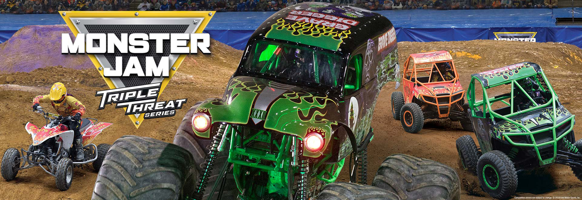

Monster Jam Triple Threat Series Returns To STAPLES Center With First-Ever SoCal Arena Truck Back Flip Stunt
**Ultimate Showdown of Eight Extreme Monster Jam Teams
Going Head-to-Head in Seven Endurance Competitions
Driving Three Different Vehicles: Monster Jam Trucks, Speedsters & ATVs**
<<TICKETS ON SALE STARTING TOMORROW MAY 7>>

(Los Angeles, CA) – After packed-crowd season of Monster Jam stadium events at Angel Stadium earlier this year, Monster Jam Triple Threat Series™ will be revving through Downtown Los Angeles with another action-packed weekend of indoor arena events at STAPLES Center that will keep motorsport fans on the edge of their seats with adrenaline-charged, high-flying, four-wheel excitement that is fun for the entire family! New this year as a special fan bonus during Freestyle driving segments, one Monster Jam truck/driver will be attempting SoCal’s FIRST-EVER Monster Jam indoor arena-based truck back flip stunt!
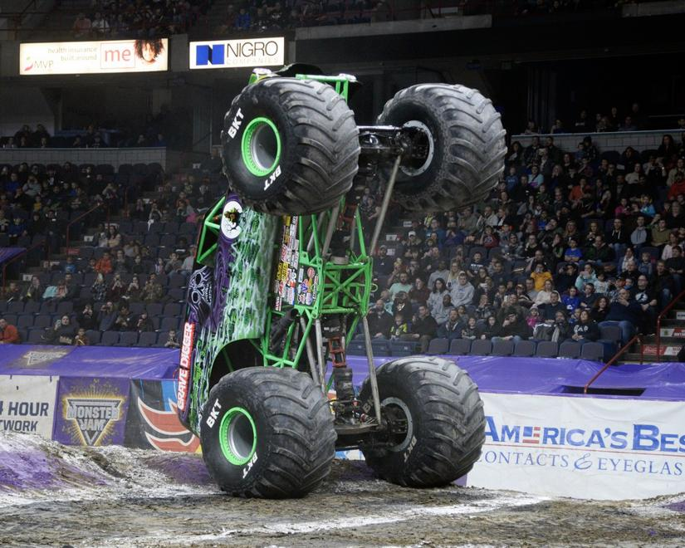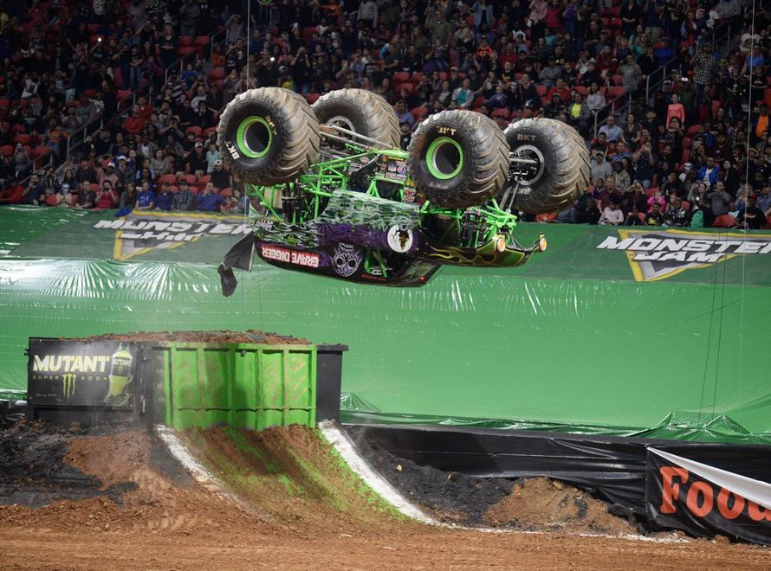

Unlike other Monster Jam events seen in SoCal/Anaheim before, the Monster Jam Triple Threat Series features eight of the most intense Monster Jam athletes in a fierce battle for the championship that tests the versatility and endurance of the athletes as they go head-to-head in a points-based format with seven different competitions driving three customized high-powered vehicles: the larger-than-life 12,000 lb. Monster Jam trucks, Monster Jam Speedsters and Monster Jam ATVs. These extreme athletes battle for points in challenging Racing and Freestyle events that push themselves and their machines to the limit – delivering what fans want to see the most… more trucks, more racing, more freestyle, more donuts, more wheelies, more action!

Monster Jam Triple Threat Series world-class athletes vying to become champions will be:
- Grave Digger® driven by Tyler Menninga (2017 Triple Threat East Series champ)
- Max-D® driven by Colton Eichelberger
- El Toro Loco® driven by Armando Castro (local Whittier hometown driver)
- Soldier Fortune™ Black Ops driven by Tony Ochs
- Scooby-Doo™ driven by Myranda Cozad
- Megalodon® driven by Austin Minton
- Zombie™ driven by Bari Musawwir
- Monster Mutt® driven by Tanner Root (2019 season rookie)
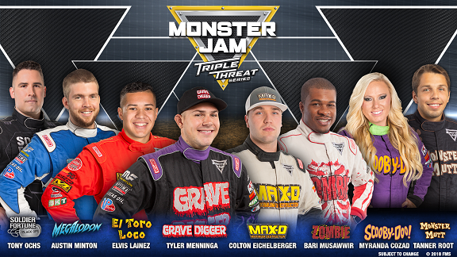

Monster Jam drivers are trained, world-class male and female athletes who have mastered not only the physical strength and mental stamina needed to compete, but the vital dexterity to control 12,000-pound machines capable of doing backflips, vertical two-wheel skills and racing at speeds up to 70 miles per hour to produce jaw-dropping, live motor sports action seen around the world. Now across all Monster Jam events, fans in every city will have the chance to vote for the winner in the two-wheel and freestyle competitions by real-time, in-stadium fan voting on their smartphones.

WHEN: Friday, July 12, 2019
- Event Time – 7:30 PM

Saturday, July 13, 2019
- Event Times – 1:00 PM & 7:00 PM

Sunday, July 14, 2019
- Event Times – 1:00 PM & 7:00 PM

WHERE: STAPLES Center – 1111 S. Figueroa Blvd, Los Angeles, CA 90011

TICKETS: Tickets are affordably priced for the whole family with seats starting at just $25 each*

Tickets are now available for purchase online at AXS.com, charge by phone at 888-9AXS-TIX or visit the venue Box Office. *ticket prices subject to change – additional venue/ticketing fees may apply

ONLINE MEDIA GUIDE: Media members can download truck/driver photos and other press materials directly at www.feldmediaguides.com/monsterjam

VIDEO PRESS KIT: B-roll videos can be downloaded via Dropbox:
MJ Triple Threat Arena VPK B-Roll
2018 Staples Center Event Highlights Reel

Back Flip Stunt B-roll links:
https://www.dropbox.com/s/z1lb82w5pq8be34/Fresno Bari Backflip Attempt.mov?dl=0
https://www.dropbox.com/s/7xls6j67jmde55d/SAC_Frist%20Back%20Flip_GD_TM_V2.mp4?dl=0

For more information on Monster Jam, please visit MonsterJam.com
Specific Staples Center event info can be found at
https://www.monsterjam.com/en-US/events/los-angeles-ca/jul-12-2019-jul-14-2019
or follow us via our social channels: Facebook, Twitter, Instagram and YouTube.

###

About Feld Entertainment®
Feld Entertainment® is the worldwide leader in producing and presenting live touring family entertainment experiences that bring people together and uplift the human spirit. Properties include Monster Jam®, Monster Energy Supercross, Disney On Ice, Disney Live!, Marvel Universe LIVE!, Sesame Street Live!, DreamWorks Trolls The Experience and Jurassic World Live (coming Fall 2019). Across the brand portfolio, Feld Entertainment has entertained millions of families in more than 75 countries and on six continents. Visit feldentertainment.com for more information.

