FOR IMMEDIATE RELEASE
June 13, 2019
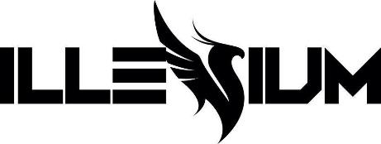

ILLENIUM ANNOUNCES NEW ALBUM, ASCEND,
DUE AUGUST 16 ON ASTRALWERKS

Special Pre-Order Opportunity Begins Today

“Good Things Fall Apart” Ft. Jon Bellion Amasses 22 Million Streams

Schedules Biggest Headline Run Yet, The ASCEND Tour, With 30 Cities In North America

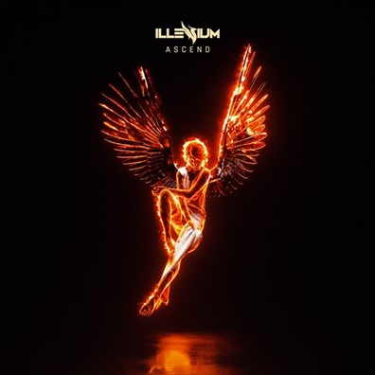
Download Artwork, Photo, Tour Art Here

Continuing a landmark 2019 highlighted by one milestone after another, Denver-based artist Nick Miller—known professionally as ILLENIUM—will release his third full-length studio album, ASCEND, on August 16 via Astralwerks. A digital pre-order just went live today on ILLENIUM.com.

In tandem with the announcement of new music, he also reveals the details for his biggest North American headline run to date, The ASCEND Tour. Produced by AEG Presents and kicking off in Pittsburgh in September, the arena jaunt will play to well over 250,000 fans in 30 cities as he canvases the country for his largest audiences ever.

Beginning today, fans who pre-order ASCEND at ILLENIUM.com will receive early access to purchase tickets for the tour starting June 19 at 10am local time. American Express® Card Members can purchase tickets before the general public beginning Wednesday, June 19 at 12pm local time through Thursday, June 20 at 10pm local time.” The general on-sale begins June 21 for all dates except for Indianapolis, Austin, Dallas & Houston, which go on sale June 28.

The ASCEND tour will see ILLENIUM hit legendary venues across North America like New York City’s Madison Square Garden on September 21, The Coca Cola Roxy in Atlanta on October 18, with the tour wrapping at the famed STAPLES Center in Los Angeles on December 7. The full itinerary can be found below. For more ticket information, visit ILLENIUM.com.

ASCEND represents entire the scope of ILLENIUM’s expansive, entrancing, and engaging vision. Once again, he elevates his signature sound with majestic melodies, intriguing instrumentation, and genre-defying songcraft. He introduced this chapter by way of the latest single “Good Things Fall Apart” with Jon Bellion. Straight out of the gate, it blasted off with stratospheric success. During its first week at radio, it became “#1 Most Added at Alternative.” Additionally, it debuted at #13 on the Billboard Dance chart. To date, total streams have surpassed 22 million and counting. Attracting acclaim, Billboard dubbed it, “a happy slice of emo-inspired with a side of radio pop.”

Check out the cinematic sci-fi music video: https://Illenium.lnk.to/GTFAVideo

ILLENIUM | Photo Credit Alexandra Gavillet

“Good Things Fall Apart” followed hot on the heels of two explosive anthems from ILLENIUM. To date, his single “Crashing” featuring Bahari has amassed nearly 40 million total streams. Meanwhile, the follow-up “Pray” featuring Kameron Alexander soundtracked a new HBO documentary. Plus, the recent “Pray” remix package engendered enthusiastic critical acclaim. Dancing Astronaut placed it on an NMF Roundup. YourEDM praised it as “intensely varied,” while RunTheTrap proclaimed it, “a phenomenal remix pack.”

This month, he’s set to touch down in George, WA for Paradiso Festival, followed by Bonnaroo Music & Arts Festival, before continuing his Las Vegas residency at Hakkasan.

ILLENIUM creates immersive emotional experiences, displaying an adeptness for crafting aural arrangements that vary in style, beauty, complexity and depth. With two full-length albums to his credit and sundry singles and remixes, he has surpassed the one billion stream mark across his discography.

His debut album, Ashes, was released to critical acclaim in early 2016. Awake followed in 2017 and hit #1 on in the iTunes Electronic Dance Charts in 12 countries. Named one of the “10 Best Dance/Electronic Albums of 2017” by Billboard, it included such singles as “Feel Good” (with Gryffin featuring Daya) and “Crawl Outta Love.” Praising the album as “a gorgeous collection of future bass, piercing vocals, and barefaced lyrics,” Dancing Astronaut said, “While it might seem premature to call an album a ‘masterpiece,’ no other title would fit Awake so well.” Billboard observed, “The phoenix is ILLENIUM 's mascot, and Awake is the emergent moment of that story.”

ILLENIUM North American Tour Dates:
Tickets: ILLENIUM.com
*Non-AEG dates
6/14/2019 George, WA Paradiso Festival
6/16/2019 Manchester, TN Bonnaroo Music and Arts Festival
6/29/2019 Las Vegas, NV Wet Republic Ultra Pool
7/5/2019 Las Vegas, NV Hakkasan Nightclub
8/24/2019 Las Vegas, NV Hakkasan Nightclub
9/18/2019 Pittsburgh, PA Stage AE
9/19/2019 Rochester, NY Main Street Armory
9/20/2019 Boston, MA Tsongas Center
9/21/2019 New York City, NY Madison Square Garden
9/26/2019 Portland, ME State Theater
9/27/2019 Montreal, QC Place Bell
9/28/2019 Toronto, ON Coca-Cola Coliseum
10/9/2019 Oklahoma City, OK The Criterion
10/10/2019 Morrison, CO Red Rocks SOLD OUT
10/11/2019 Morrison, CO Red Rocks SOLD OUT
10/12/2019 Morrison, CO Red Rocks SOLD OUT (Throwback Set)
10/17/2019 Nashville, TN Municipal Auditorium
10/18/2019 Atlanta, GA Coca-Cola Roxy*
10/19/2019 Tampa, FL Yuengling Center
11/2/2019 Detroit, MI The Masonic Temple
11/5/2019 Indianapolis, IN Egyptian Room*
11/6/2019 St. Louis, MO The Pageant
11/8/2019 Chicago, IL UIC Pavilion
11/9/2019 Minneapolis, MN The Armory
11/10/2019 Madison, WI The Sylvee*
11/15/2019 Austin, TX Stubb's Waller Creek Amphitheater*
11/16/2019 Dallas, TX Toyota Music Factory*
11/17/2019 Houston, TX Revention Music Center*
11/20/2019 Kansas City, MO Arvest Bank Theatre
11/22/2019 Salt Lake City, UT The Great Saltair
11/23/2019 Reno, NV Reno Event Center
11/24/2019 Boise, ID Revolution Center*
11/27/2019 Seattle, WA WaMu Theater
11/29/2019 Seattle, WA WaMu Theater (Throwback Set)
11/30/2019 Vancouver, BC PNE Forum
12/1/2019 Portland, OR Veterans Memorial Coliseum
12/6/2019 San Diego, CA Pechanga Arena San Diego
12/7/2019 Los Angeles, CA STAPLES Center

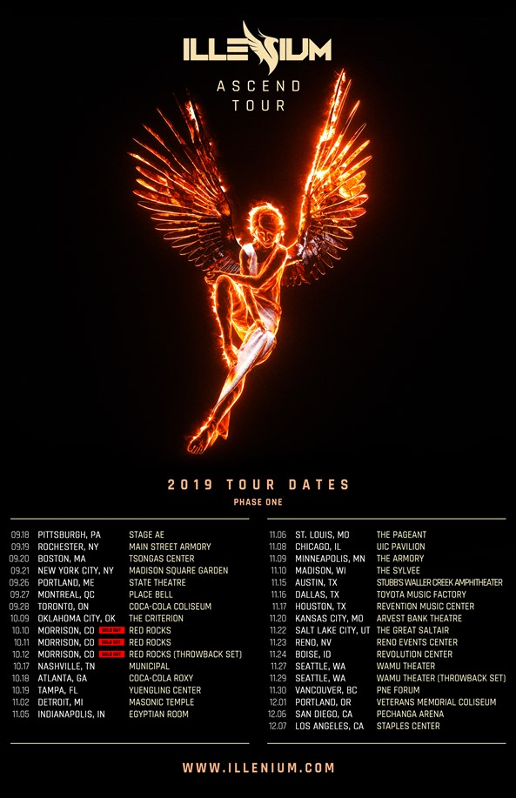

About AEG Presents:
AEG Presents is one of the largest live music companies in the world. The company is dedicated to all aspects of live contemporary music performances, including producing and promoting global and regional concert tours, music events and world-renowned festivals. AEG Presents operates in North America, Europe and Asia through 16 regional offices that support its tours which include such artists as Taylor Swift, Paul McCartney, Elton John, The Rolling Stones, Justin Bieber, BTS, Ed Sheeran, Katy Perry, Panic! at the Disco, Luke Combs and Kenny Chesney; produce or support over 25 music festivals, including the iconic Coachella Valley Music & Arts Festival, Stagecoach, the New Orleans Jazz & Heritage Festival, Hangout Festival, Electric Forest, and Firefly; and owns, manages or books more than 80 clubs and theaters. AEG Presents produces and promotes more than 11,000 shows annually worldwide and conducts business under such globally renowned brands as AEG Presents, Goldenvoice, The Bowery Presents, Concerts West, Messina Touring Group, Marshall Arts LTD, Madison House Presents, Zero Mile and PromoWest Productions.

Follow ILLENIUM:
Website | Facebook | Twitter | Instagram | YouTube

###

For more information contact:
MacKenzie Reynolds / Capitol Music Group
(323) 871-5387
Mackenzie.reynolds@umusic.com

