GLOBAL SUPERSTARS ENRIQUE IGLESIAS AND RICKY MARTIN ANNOUNCE FIRST EVER CO-HEADLINING ARENA TOUR
IN NORTH AMERICA

Latin’s Rising Star Sebastián Yatra to Perform as Special Guest On Momentous Outing

Citi / AAdvantage Presale Begins Tuesday, March 10th;
Tickets On Sale to the General Public Starting Thursday, March 12th

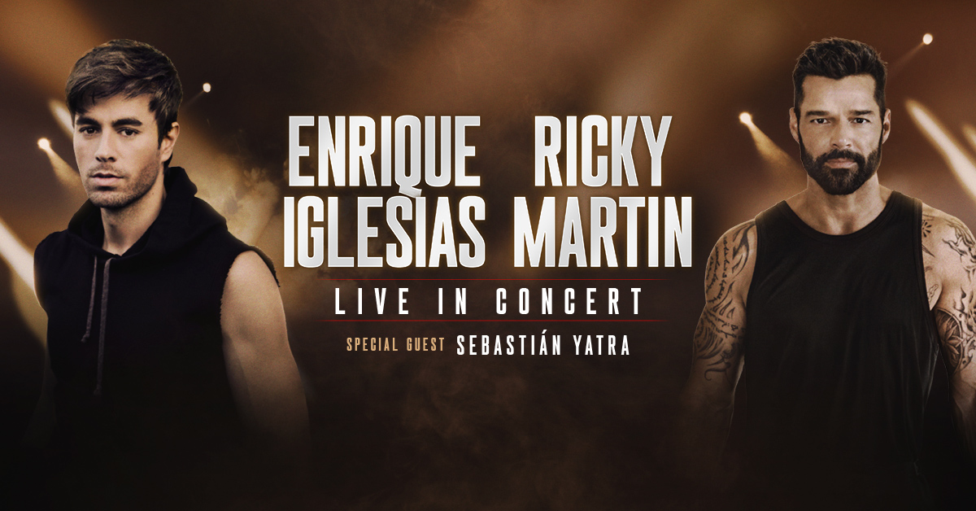

Enrique Iglesias Press Photo
Ricky Martin Press Photo

LOS ANGELES, CA (March 4, 2020) – GRAMMY Award-winning, multi-platinum powerhouse artists Enrique Iglesias and Ricky Martin are hitting the road together for the first time ever. The global superstars have built unstoppable solo careers with dozens of #1 songs and millions of albums between them, and are now joining forces live in concert this fall. Fans can expect to hear renowned hits from two of the biggest names in pop and Latin music on their historic North American arena tour. Latin music’s newest sensation Sebastián Yatra will join the outing as special guest. The GRAMMY nominee has become one of the most powerful Latin pop artists of his generation.

Produced by Live Nation, the outing will kick off September 5th in Phoenix and make stops in Houston, Los Angeles, Toronto, New York, Miami, and more before wrapping October 30th in Atlanta. Tickets go on sale to the general public starting Thursday, March 12th at LiveNation.com at 10 a.m. local time.

Citi® / AAdvantage® is the official credit card for the presale of the U.S. tour. As such, Citi / AAdvantage cardmembers will have access to purchase presale tickets beginning Tuesday, March
10th at 10:00 a.m. local time until Wednesday March 11th at 10:00 p.m. local time through the Citi Entertainment® program. For complete presale details visit www.citientertainment.com.

Both artists will continue taking care of longstanding fans with their own exclusive fan presales making sure hardcore followers have access to amazing seats as well.

A limited number of LaneOne Premium Packages will also be available, including amazing seats, transportation, preferred entrance, preshow hospitality and more. Check HERE for LaneOne details.

Enrique and Ricky have created some of pop music’s most memorable songs for decades and their combined list of chart-toppers is seemingly endless. Enrique gained devoted fans around the world with songs including “Hero,” “Escape,” “Bailando,” “Tonight,” and more recent hits “Subeme La Radio” and “Duele El Corazon” with a new album to be released later this year. Ricky’s solo career exploded with “The Cup of Life" and “Livin’ La Vida Loca,” followed by “She Bangs,” “Vente Pa’ Ca,” and his most recent “Tiburones” from his upcoming 2020 studio album. The two will perform a worldclass setlist of their top hits when the tour kicks off this September.

Special guest Sebastián Yatra made his mark on Latin pop with the album Fantasia, which debuted at #1 on Billboard’s Latin pop album chart. He received a 2020 GRAMMY Nomination for “Best Latin Pop Album” along with two Latin American Music Awards and four Latin GRAMMY Awards nominations.

DATE | CITY | VENUE
Saturday, September 5, 2020 | Phoenix, AZ | Gila River Arena
Sunday, September 6, 2020 | El Paso, TX | Don Haskins Center
Wednesday, September 9, 2020 | Edinburg, TX | Bert Ogden Arena
Friday, September 11, 2020 | San Antonio, TX | AT&T Center
Saturday, September 12, 2020 | Houston, TX | Toyota Center
Sunday, September 13, 2020 | Dallas, TX | American Airlines Center
Thursday, September 17, 2020 | Los Angeles, CA | STAPLES Center
Tuesday, September 22, 2020 | San Jose, CA | SAP Center
Thursday, September 24, 2020 | Sacramento, CA | Golden 1 Center
Saturday, September 26, 2020 | Las Vegas, NV | MGM Grand Garden Arena
Thursday, October 1, 2020 | Chicago, IL | Allstate Arena
Tuesday, October 6, 2020 | Boston, MA | TD Garden
Thursday, October 8, 2020 | Toronto, ON | Scotiabank Arena
Saturday, October 10, 2020 | Montreal, QC | Centre Bell
Wednesday, October 14, 2020 | Philadelphia, PA | Wells Fargo Center
Thursday, October 15, 2020 | Washington, DC | Capital One Arena
Saturday, October 17, 2020 | Newark, NJ | Prudential Center
Sunday, October 18, 2020 | New York, NY | Madison Square Garden
Friday, October 23, 2020 | Miami, FL | AmericanAirlines Arena
Thursday, October 29, 2020 | Orlando, FL | Amway Center
Friday, October 30, 2020 | Atlanta, GA | State Farm Arena
Enrique Iglesias Social Channels:
www.enriqueiglesias.com
www.instagram.com/enriqueiglesias
www.facebook.com/enriqueiglesias
www.youtube.com/enriqueiglesias
www.twitter.com/enriqueiglesias

Ricky Martin Social Channels:
www.instagram.com/ricky_martin
www.facebook.com/rickymartinofficialpage.com
www.youtube.com/rickymartinVEVO
www.twitter.com/ricky_martin

About Live Nation Entertainment
Live Nation Entertainment (NYSE: LYV) is the world’s leading live entertainment company comprised of global market leaders: Ticketmaster, Live Nation Concerts, and Live Nation Sponsorship. For additional information, visit www.livenationentertainment.com.

Enrique Iglesias English/Anglo Media Contact:
Meghan Kehoe, Meghan.Kehoe@rcarecords.com

Enrique Iglesias Spanish Media Contact:
Joe Bonilla, joe@latinvasion.com

Ricky Martin English/Anglo Media Contact:
Karynne Tencer, karynne@tencerpr.com

Ricky Martin Spanish Media Contact:
Rondine Alcala, rondinealcala@rondenepr.com

Live Nation U.S. Concerts Media Contact:
Monique Sowinski, moniquesowinski@livenation.com

