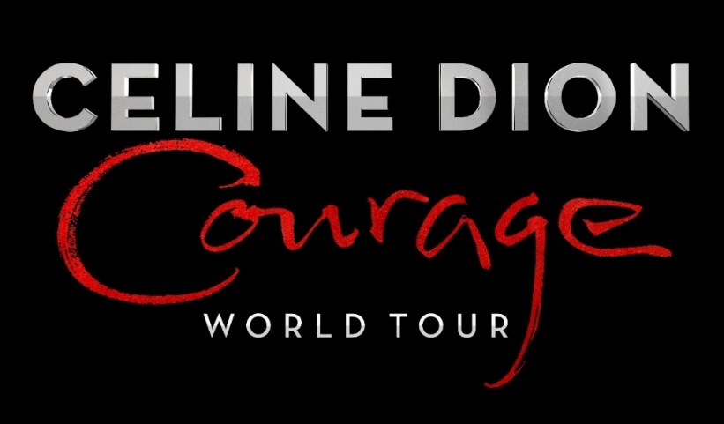

WORLD-RENOWNED GLOBAL ICON CELINE DION ANNOUNCES ADDITIONAL NORTH AMERICAN DATES FOR
“COURAGE WORLD TOUR”

HITTING NEARLY 100 CITIES WORLDWIDE

COMING TO STAPLES CENTER IN LOS ANGELES ON APRIL 2 & 3
TICKETS ON-SALE FRIDAY, OCTOBER 4 AT 10AM

FORTHCOMING ALBUM COURAGE SET FOR RELEASE NOVEMBER 15

FOR DOWNLOAD:
COURAGE WORLD TOUR Announcement Video & Performance B-Roll
Photos

New York, NY – September 26, 2019 – One of the most immediately recognized and widely respected superstars in pop music history, Celine Dion, announces additional dates for her COURAGE WORLD TOUR, which includes new North American dates and international dates. The tour kicked off on September 18 in Québec City, which marks her first tour in the U.S. in over 10 years, and will include first time appearances in Malta and Cyprus.

The COURAGE WORLD TOUR, which supports Celine’s first English album in 6 years, will be stopping in nearly 100 cities worldwide. A third show has been added by demand in Brooklyn, NY as well as a number of West Coast dates including San Diego and San Francisco, CA. European stops include Prague, Budapest, Munich, Paris, Berlin, Stockholm, London, and many more. The tour is produced by Concerts West/AEG Presents.

Celine Dion will bring her COURAGE WORLD TOUR to Los Angeles’ STAPLES Center on April 2 & 3. Tickets will go on-sale Friday, October 4, at 10am local and can be purchased HERE.

Members of Team Celine will have access to purchase tickets before the public through an advance pre-sale. Tickets for the additional North American dates will go on-sale to the public beginning Friday, October 4 at 10am local time. American Express® Card Members can purchase tickets before the public beginning Monday, September 30th at 10am local time through Thursday, October 3rd at 10pm local time.

Exclusive VIP packages will be available.

Last week, Celine Dion released three new tracks, from her highly anticipated upcoming album also entitled Courage. “Imperfections,” “Lying Down,” and “Courage” represent an exciting new creative direction for Celine and fans will have a chance to hear songs from the new album throughout the journey of the COURAGE WORLD TOUR. Premiering today, is the video for “Imperfections” – watch HERE. Courage, an eclectic mixture of beautiful ballads and edgy up-tempo tracks, will be available everywhere November 15 and is available for pre-order now. Listen to the newly released tracks HERE.

Additionally, all online ticket orders for the North American leg of the COURAGE WORLD TOUR come with one CD copy of Celine’s Courage album.

See full list of new tour dates below. For tickets and full tour schedule visit celinedion.com.

CELINE DION COURAGE WORLD TOUR additional U.S. and Canada dates going on-sale Friday, October 4 at 10am local time:

# New show date

3/5 | Brooklyn, NY | Barclays Center
3/24 | Denver, CO | Pepsi Center
3/26 | Salt Lake City, UT | Vivint Smart Home Arena
3/29 | Glendale, AZ | Gila River Arena#
3/31 | San Diego, CA | Pechanga Arena
4/2-4/3 | Los Angeles, CA | STAPLES Center
4/7 | Sacramento, CA | Golden 1 Center
4/9 | Oakland, CA | Oakland Arena
4/10 | San Francisco, CA | Chase Center#
4/13 | Portland, OR | Moda Bank
4/15 | Tacoma, WA | Tacoma Dome
4/17-4/18 | Vancouver, BC | Rogers Arena
4/21 | Edmonton, AB | Rogers Place
4/25 | Saskatoon, SK | SaskTel Centre
4/27 | Winnipeg, MB | Bell MTS Place

About Celine Dion
Vocal powerhouse Celine Dion is one of the most immediately recognized, widely respected and successful performers in pop music history. She won numerous awards by the age of 18, dominated the pop charts in 1990s and has sold almost 250 million albums during her over 35-year career. She has earned five Grammy Awards, two Academy Awards, seven American Music Awards, 20 Juno Awards (Canada) and an astonishing 40 Félix Awards (Quebec). She remains one of the most sought-after recording artists, receiving the Diamond award at the 2004 World Music Awards recognizing her status as the best-selling female artist of all time. In 2016 the Billboard Music Awards presented her with the lifetime achievement Icon Award. Celine continues to break records with her Las Vegas residency at The Colosseum at Caesars Palace which has played over 1,100 shows to more than 4.5 million fans. In June 2018, Celine took a two-month hiatus from her Las Vegas residency to head overseas for her sold-out tour CELINE DION LIVE 2018, playing 22 shows across 12 cities in Asia, Australia and New Zealand. The tour was one of the highest-grossing of the year, grossing nearly $57 million for 260,000 fans. She also topped the US Dance Club charts in July 2018 with the remix of her single Ashes from the Deadpool 2 movie. On June 8, 2019, Celine Dion’s iconic 16-year Las Vegas residency came to an end.

About AEG Presents
AEG Presents is one of the largest live music companies in the world. The company is dedicated to all aspects of live contemporary music performances, including producing and promoting global and regional concert tours, music events and world-renowned festivals. AEG Presents operates in North America, Europe and Asia through 16 regional offices that support its tours which include such artists as Taylor Swift, Paul McCartney, Elton John, The Rolling Stones, Justin Bieber, BTS, Ed Sheeran, Katy Perry and Kenny Chesney; produce or support over 25 music festivals, including the iconic Coachella Valley Music & Arts Festival, Stagecoach, the New Orleans Jazz & Heritage Festival, Hangout Festival, Electric Forest, and Firefly; and owns, manages or books more than 100 clubs and theaters. AEG Presents produces and promotes more than 11,000 shows annually worldwide and conducts business under such globally renowned brands as AEG Presents, Goldenvoice, The Bowery Presents, Concerts West, Messina Touring Group, Marshall Arts LTD, Madison House Presents and PromoWest Productions. For more information visit www.aegpresents.com.

http://www.celinedion.com/
https://www.facebook.com/celinedion/
https://twitter.com/celinedion
https://www.instagram.com/celinedion
@CelineDion
#CourageWorldTour
www.aegpresents.com

Please direct all COURAGE WORLD TOUR media requests to:

Rogers & Cowan:
Michelle Nemeroff | mnemeroff@rogersandcowan.com | 212-878-5111
Fran Curtis | fcurtis@rogersandcowan.com | 212-878-5002

STAPLES Center:
Samantha Marker | smarker@aegworldwide.com | 213-742-7293

