**Multi-Platinum Global Superstar Chris Brown**

**Announces *INDIGOAT Tour* with**

**Tory Lanez, Ty Dolla $ign, Joyner Lucas**

**and Yella Beezy**

**Tickets On Sale To General Public Starting Friday, June 14**

**With Option to Buy New Album with Every Two Tickets Purchased**

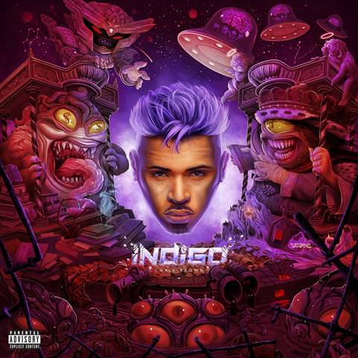

**Highly Anticipated 9th Studio Album**

***INDIGO***

**To Arrive June 28; Pre-Order Available Now**

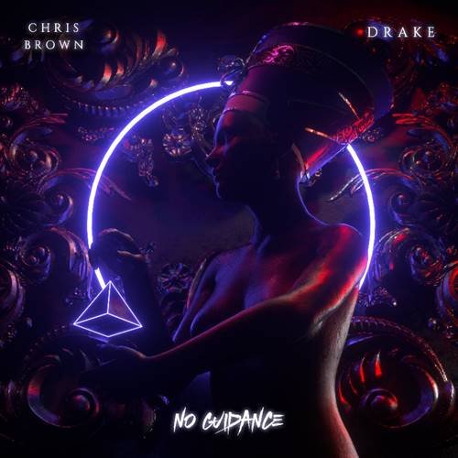

**“No Guidance” Single Featuring**

**International Hitmaker Drake**

**Available on all Music Platforms**

[LOS ANGELES, CA - June 10, 2019] Global music icon, world-class entertainer and Grammy Award winner **Chris Brown** will be hitting the road for the epic ***INDIGOAT Tour*** with some of the hottest names in hip-hop including **Tory Lanez, Ty Dolla $ign, Joyner Lucas** and **Yella Beezy.** Following last year’s highly successful Heartbreak on a Full Moon Tour*,* Brown is returning to the stage, where he’ll wow audiences across the U.S. with a fresh high-energy show complete with his signature dance skills and strong vocals, as well as new music.

Tickets go on sale to the general public beginning Friday, June 14th at 12pm local time at [LiveNation.com](https://eur01.safelinks.protection.outlook.com/?url=https%3A%2F%2Fwww.livenation.com%2Fartists%2F81108%2Fchris-brown&data=02%7C01%7Camanda.zimmerman%40rcarecords.com%7C71cee87b6c0f43c5d04308d6eb87ce87%7Cf0aff3b791a54aaeaf71c63e1dda2049%7C0%7C0%7C636955365853648063&sdata=rgep1OEoL9l3PW92HBA6tHLnISMfcxQ1LmqVOqMHCcQ%3D&reserved=0). Citi is the official presale credit card of the INDIGOAT Tour. As such, Citi cardmembers will have access to purchase presale tickets beginning Wednesday, June 12th at 12pm local time until Thursday, June 13th at 10pm local time through Citi EntertainmentSM. For complete presale details visit [www.citientertainment.com](https://eur01.safelinks.protection.outlook.com/?url=http%3A%2F%2Fwww.citientertainment.com&data=02%7C01%7Camanda.zimmerman%40rcarecords.com%7C71cee87b6c0f43c5d04308d6eb87ce87%7Cf0aff3b791a54aaeaf71c63e1dda2049%7C0%7C0%7C636955365853658061&sdata=H55YSr8PPDyAHYrj%2BfkH0FnNky3UbgXwqbDnSlKDeIk%3D&reserved=0). With every two tickets purchased, fans will also have the option to buy *INDIGO*.

Ahead of the tour, fans can look forward to Brown’s highly anticipated 9th studio album, ***INDIGO,*** out **June 28th** via RCA Records, with star-studded features from **Justin Bieber, Nicki Minaj, G-Eazy, Juicy J, Trey Songz, Tory Lanez, Tyga, H.E.R., Lil Jon, Joyner Lucas, Gunna and Tank**. Coming off the heels of catchy tracks, such as “Wobble Up,” “Back to Love,” and “Undecided,” Brown has teamed up withglobal superstar **Drake** for the album’s new smash, **“No Guidance”** produced by Vinylz, J-Louis and Noah “40” Shebib. The single is available now on all platforms [here](https://smarturl.it/NoGuidance). The 33-track *INDIGO* album is available for pre-order now [here](https://smarturl.it/xIndigo), and Apple Music subscribers who pre-order the album will receive “No Guidance” as an instant download.

[CLICK HERE TO PRE-ORDER *INDIGO*](https://eur01.safelinks.protection.outlook.com/?url=https%3A%2F%2Fsmarturl.it%2FxIndigo&data=02%7C01%7Camanda.zimmerman%40rcarecords.com%7C71cee87b6c0f43c5d04308d6eb87ce87%7Cf0aff3b791a54aaeaf71c63e1dda2049%7C0%7C0%7C636955365853668052&sdata=xCKA0%2BpuxcUUZ5AS%2FrWBqOxK6%2FT%2B1lXvaUEzdZrH%2FA0%3D&reserved=0)

[CLICK HERE TO STREAM “NO GUIDANCE”](https://eur01.safelinks.protection.outlook.com/?url=https%3A%2F%2Fsmarturl.it%2FNoGuidance&data=02%7C01%7Camanda.zimmerman%40rcarecords.com%7C71cee87b6c0f43c5d04308d6eb87ce87%7Cf0aff3b791a54aaeaf71c63e1dda2049%7C0%7C0%7C636955365853668052&sdata=doHFTMXqTXK7T0tfrIJVe9qGNL1MyXr902IpY9s7j%2Fo%3D&reserved=0)

Fans attending the tour can expect a remarkable set list with a mix of Brown’s classic hits and new tracks from his new album. Kicking off August 20th in Portland, OR, the extensive 38-city tour produced by Live Nation will make stops at major arenas in New York, Chicago, Houston, Los Angeles, and more, before wrapping in Anaheim, CA on October 19th.

***INDIGOAT Tour* 2019 U.S. Dates:**

|  |  |  |
| --- | --- | --- |
| **DATE** | **CITY** | **VENUE** |
| Tue Aug 20 | Portland, OR | Moda Center |
| Wed Aug 21 | Tacoma, WA | Tacoma Dome |
| Fri Aug 23 | Salt Lake City, UT | Vivint Smart Home Arena |
| Sat Aug 24 | Denver, CO | Pepsi Center |
| Mon Aug 26 | Oklahoma City, OK | Chesapeake Energy Arena |
| Wed Aug 28 | New Orleans, LA | Smoothie King Center |
| Fri Aug 30 | Jacksonville, FL | Vystar Memorial Arena |
| Sat Aug 31 | Tampa, FL | Amalie Arena |
| Sun Sep 01 | Sunrise, FL | BB&T Center |
| Wed Sep 04 | Nashville, TN | Bridgestone Arena |
| Fri Sep 06 | Raleigh, NC | PNC Arena |
| Sat Sep 07 | Charlotte, NC | Spectrum Center |
| Sun Sep 08 | Hampton, VA | Hampton Coliseum |
| Tue Sep 10 | Buffalo, NY | KeyBank Center |
| Wed Sep 11 | Albany, NY | Times Union Center |
| Fri Sep 13 | Newark, NJ | Prudential Center |
| Sat Sep 14 | Brooklyn, NY | Barclays Center |
| Tue Sep 17 | Philadelphia, PA | Wells Fargo Center |
| Wed Sep 18 | Allentown, PA | PPL Center |
| Fri Sep 20 | Boston, MA | TD Garden |
| Sat Sep 21 | Hartford, CT | XL Center |
| Sun Sep 22 | Washington, DC | Capital One Arena |
| Tue Sep 24 | Pittsburgh, PA | PPG Paints Arena |
| Wed Sep 25 | Columbus, OH | Nationwide Arena |
| Thu Sep 26 | Chicago, IL | United Center |
| Sat Sep 28 | Indianapolis, IN | Bankers Life Fieldhouse |
| Mon Sep 30 | Detroit, MI | Little Caesars Arena |
| Wed Oct 02 | St. Louis, MO | Enterprise Center |
| Sat Oct 05 | Dallas, TX | American Airlines Center |
| Sun Oct 06 | Houston, TX | Toyota Center |
| Tue Oct 08 | San Antonio, TX | AT&T Center |
| Thu Oct 10 | Phoenix, AZ | Talking Stick Resort Arena |
| Fri Oct 11 | Los Angeles, CA | Staples Center |
| Sat Oct 12 | Sacramento, CA | Golden 1 Center |
| Tue Oct 15 | Oakland, CA | Oracle Arena |
| Thu Oct 17 | Fresno, CA | Save Mart Center |
| Fri Oct 18 | San Diego, CA | Viejas Arena |
| Sat Oct 19 | Anaheim, CA | Honda Center |

**About Chris Brown:**

Chris Brown, a consummate entertainer who has shifted the climate of R&B culture since his eponymous 2005 debut, has sold in excess of 30 million albums worldwide and has surpassed over 10 billion audio streams across digital outlets to date. Brown has won more than 125 awards including a Grammy Award for his album F.A.M.E. in 2011 and has amassed over 7.5 billion YouTube views - including over 40 music videos that each have more than 100 million views earning him the title of male artist with the most Vevo certified videos ever and 'Diamond' status from the streaming platform.

A chart topping force, Brown has made more Billboard Hot 100 entries since the start of his career than any contemporary male singer alive to date, spending 160 consecutive weeks charting on the Hot 100. His last album *Heartbreak On A Full Moon* has been streamed over 1 billion times on Spotify and has been certified 2X platinum. The album spent more than a year on the Billboard Hot 200.

An accomplished entrepreneur and business owner, Brown’s tenacity behind his venture into fashion with his Black Pyramid brand has transformed his business from a digital fashion giant to acquiring a worldwide distribution deal and being carried in major retailers globally. In addition, Brown’s commitment to philanthropy is as important to him as his professional pursuits - including his dedication to the Symphonic Love Foundation, a charitable organization that he founded which supports and creates arts programs for youth. Brown has also donated his time and resources to various non-for-profit organizations including St. Jude Children’s Hospital, Best Buddies, Hurricane Harvey victims, and Colin Kaepernick’s recent “10 for 10” million dollar pledge.

**About Live Nation Entertainment**

Live Nation Entertainment (NYSE: LYV) is the world’s leading live entertainment company comprised of global market leaders: Ticketmaster, Live Nation Concerts, and Live Nation Sponsorship. For additional information, visit [www.livenationentertainment.com](https://eur01.safelinks.protection.outlook.com/?url=http%3A%2F%2Fwww.livenationentertainment.com&data=02%7C01%7Camanda.zimmerman%40rcarecords.com%7C71cee87b6c0f43c5d04308d6eb87ce87%7Cf0aff3b791a54aaeaf71c63e1dda2049%7C0%7C0%7C636955365853678046&sdata=PUxUxFHDl8T1demnwolFqbG2C8ADe6R9RxuRn1ixXkc%3D&reserved=0).

For **Chris Brown**, contact:

Chris Chambers, The Chamber Group

[chris@thechambergroup.com](mailto:chris@thechambergroup.com)

Shannon Atran, The Chamber Group

[shannon@thechambergroup.com](mailto:shannon@thechambergroup.com)

Theola Borden, RCA Records

[theola.borden@rcarecords.com](mailto:theola.borden@rcarecords.com)

For **Live Nation U.S. Concerts**, contact:

Emily Bender

[EmilyBender@LiveNation.com](mailto:EmilyBender@LiveNation.com)

Monique Sowinski

[MoniqueSowinski@LiveNation.com](mailto:MoniqueSowinski@LiveNation.com)